D R A F T
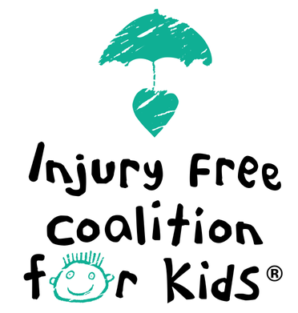
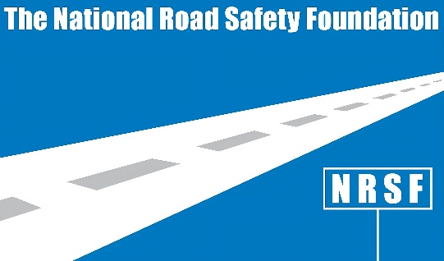

INJURY FREE COALITION FOR KIDS AND NATIONAL ROAD SAFETY FOUNDATION
CALL FOR SOCIAL MEDIA POSTS TO FOCUS ATTENTION ON PEDIATRIC VEHICULAR HEATSTROKE
More than 1,000 children have died in overheated cars since 1998

NEW YORK, March 4, 2026 -- More than 1,000 children have died in hot cars since 1998 due to Pediatric Vehicular Heatstroke (PVH). All those deaths were preventable, says the Injury Free Coalition for Kids (IFCK), comprised of 42 hospital-based, community-oriented programs whose efforts are anchored in research, education and advocacy.
To help reduce this heartbreaking toll, IFCK is partnering with the National Road Safety Foundation to host a challenge to the health and medical community to help design a social media post that grabs parents' and caregivers’ attention.

The challenge is open to post-graduate students in a medical school, nursing school, or school of public health program, medical residents and Fellows, and pediatric and ED nurses throughout the U.S.

The National Road Safety Foundation will award up to three prizes totaling $5,000 to the top entries, with $2,500 for first prize, $1,500 and $1,000 for second and third prizes.

Submissions will be accepted through April 15, 2026. Entries approved by the judging panel will be made available for public voting online for a two-week period beginning May 1, and winning entries will be announced on or about May 15, to coincide with National Trauma Awareness Month.

Entry information and rules are at https://www.injuryfree.org/ or email info@injuryfree.org.

